Name: Mamata kc

Roll no : 5805

Section=A

1. Adding files to the new folder.

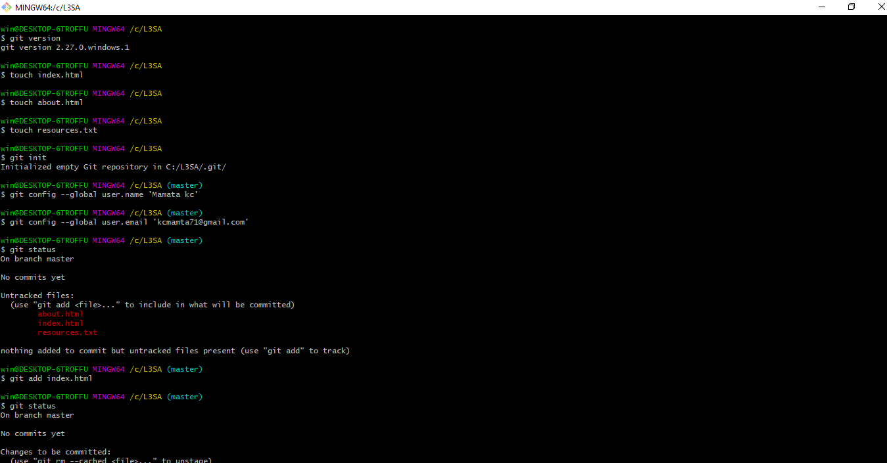

2. Writing on resources. txt, index.html , touch about html and initializing the Git repository / working directory and configuring user name and email and checking the status and adding files.



3. Checking the status and applying changes/adding texts in the document and checking the status.

(Optional) and adding the file and committing the change and viewing the commit history.

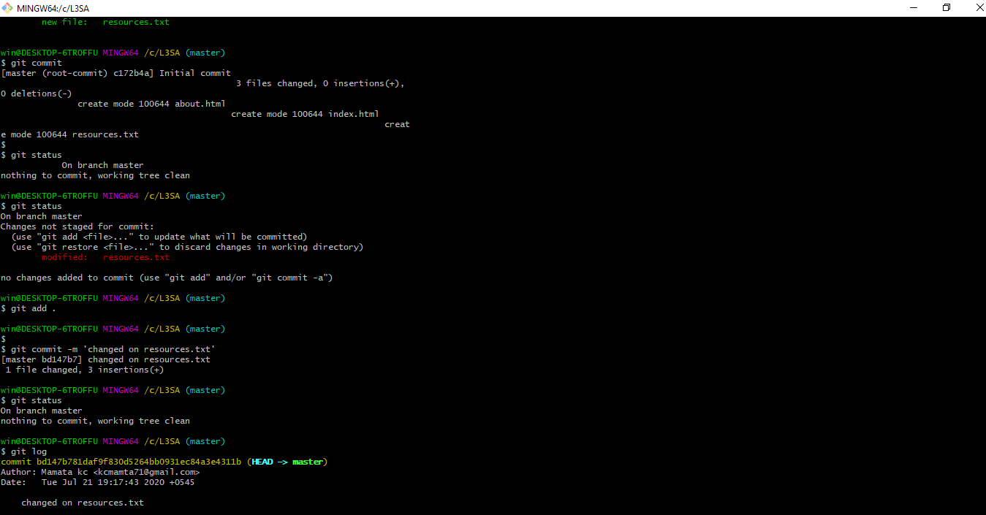

Task 2;

4. New repository named Mina git created and adding the origin and pushing the files.

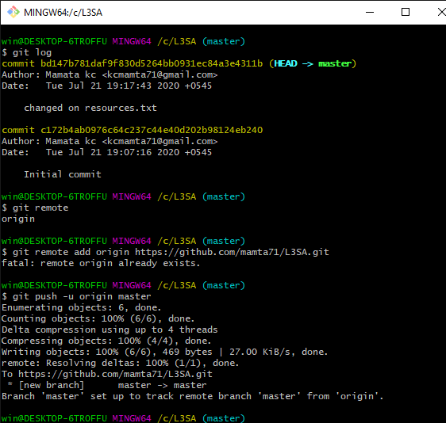

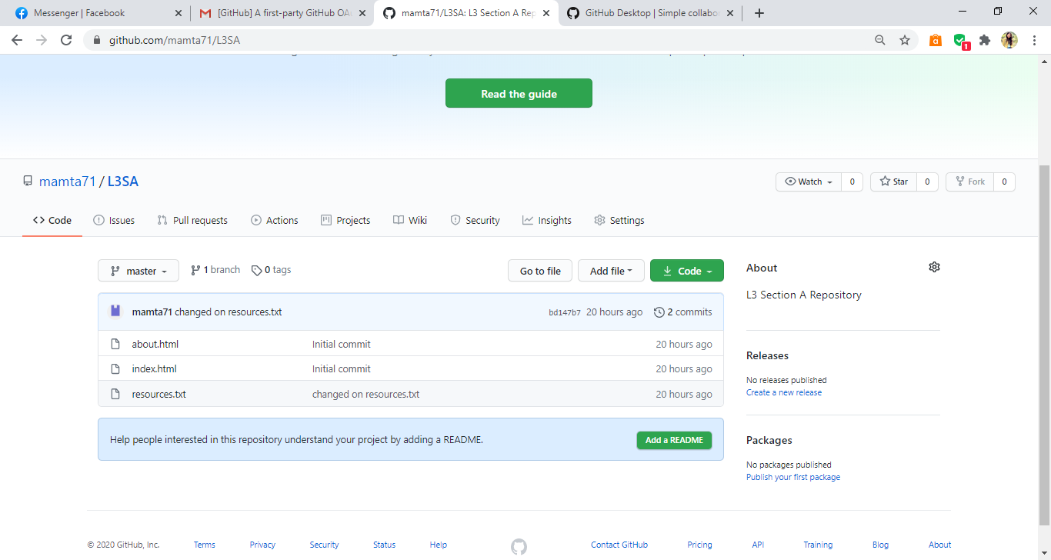

5. Cloning the github repository.

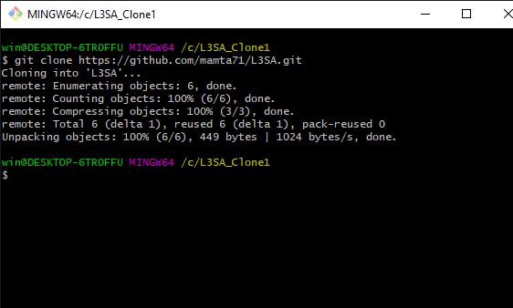

Task 3;

6. Creating a new branch “Branch-1” and switching to the new branch and adding files on the new

branch and committing the changes and pushing the new branch on github.

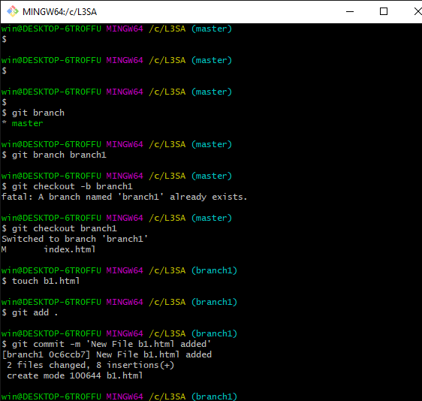

Task 4;

7. Successfully downloaded and logged in to github desktop.

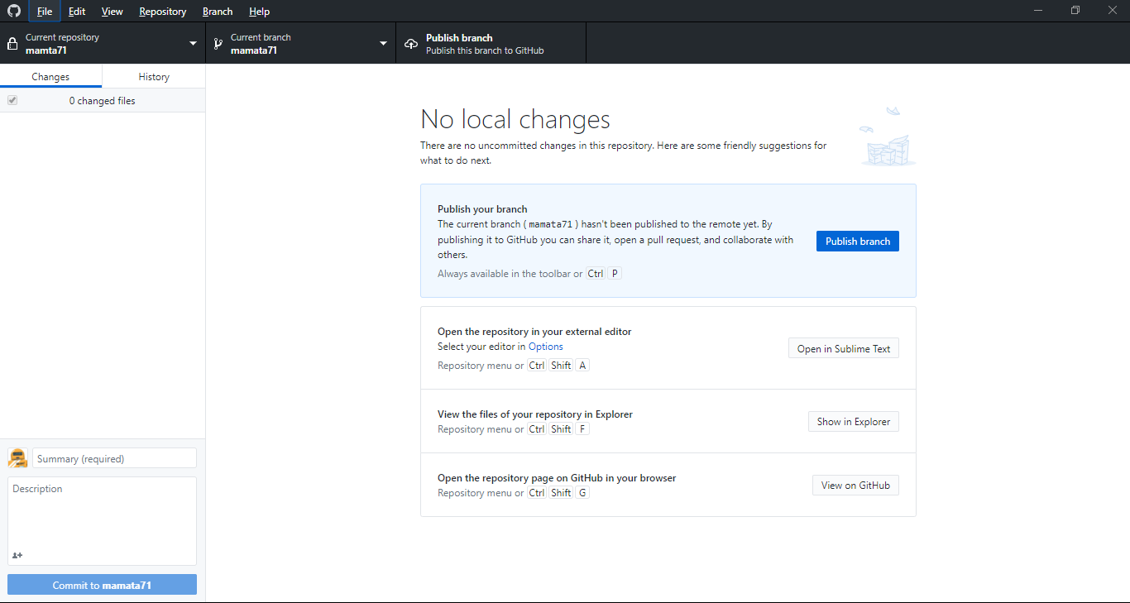

8. Creating a new file in local repository, committing and pushing it to GitHub using GitHub Desktop.

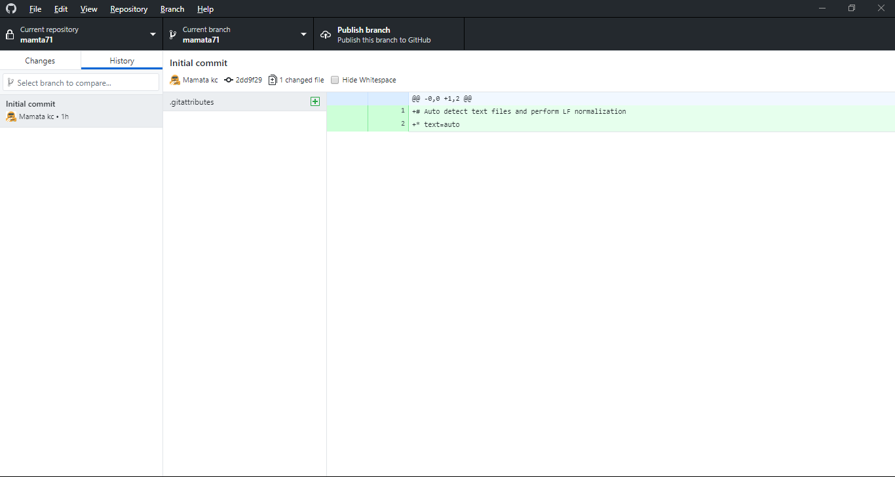

9. Publishing and pulling the current branch in github desktop.



Link to the github= <https://github.com/mamta71/L3SA/tree/master>